**Strategic Management**

**Final Report**

**Company: EFU General Insurance**

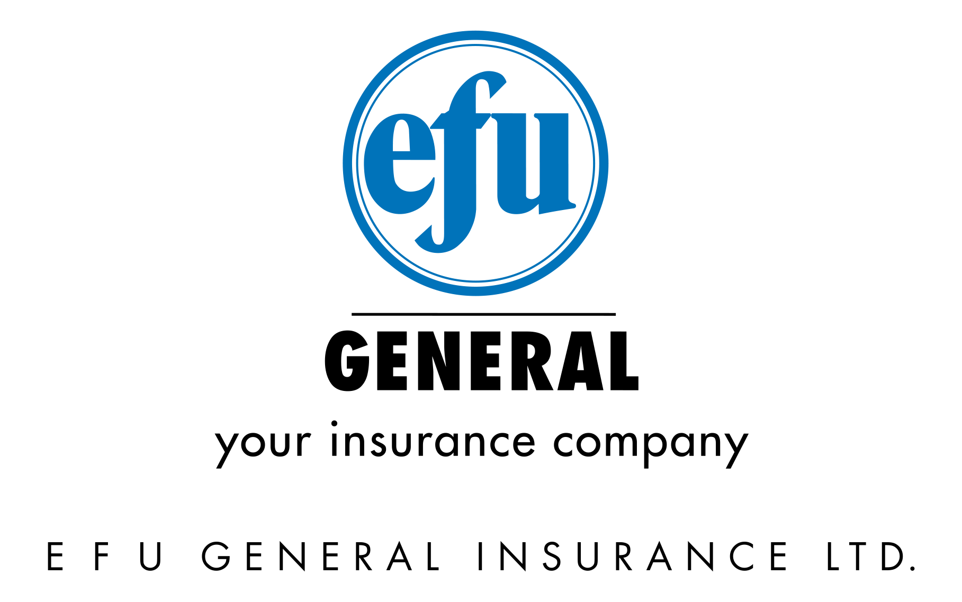**Submitted to: Dr. Saad Usmani**

**Group Members:  
Ahmed Raza Qadri**

**Ahsan Tariq**

**Amin Ur Rehman**

**Areeb Saleem**

**Muhammad Yasir**

**Nabeel Ahmed**

**ACKNOWLEDGEMENTS**

First of all, all the praises to ALMIGHTY ALLAH for giving us the ability to think, do and deliver on what we were assigned to do. Secondly, we extend our thankful regards to our mentor and facilitator in the course of strategic management Dr. Saad Usmani for providing us the opportunity to present the project in front of him. We would also like to thank our course facilitator for guiding us throughout the project and providing assistance whenever needed. We would also like to thank Mr. Adeel Ahmed (Senior Executive Vice President [Development]) for taking out some precious time from his busy schedule to provide us relevant information related to the company. Lastly, we would like to thank each and every group member for their valuable contributions within the project and working as a team to complete the project within the given deadline and working wholeheartedly for this project.

**Preface**

The following is the final report for the course of strategic management which was the final requirement of course facilitated by Dr. Saad Usmani. The purpose of this report is to assess the strategic management within a company based on certain components that were part of course and the learning and understandings in the class have been applied in a real world scenario. The company chosen for fulfillment of this purpose is EFU general insurance.

**Executive Summary**

TABLE OF CONTENTS

Introduction 5

Company Overview 6

Vision 6

Mission 6

Values 6

Department of EFU General: 6

Underwriting Department 6

Claim Department 7

Reinsurance Department 7

Products and Services of EFU 8

Motor Insurance 8

Marine Cargo 8

Marine Hull 8

Miscellaneous 9

Fire Insurance 9

Risk Management 9

SWOT Analysis 10

Strengths 10

Weaknesses 11

Opportunities 11

Threats 11

Ratios Analysis 12

Liquidity Ratios 12

Current ratio 12

Leverage Ratios 12

Debt to Total Assets 12

Debt to Equity 12

Activity Ratios 13

Fixed Assets Turnover 13

Total Asset Turnover 13

Profitability Ratios 13

Gross Profit Margin 13

Operating Profit Margin 14

Net Profit Margin 14

Return on Total Assets 14

Return on Equity 15

Earnings per Share 15

Price/Earnings Ratio 15

Sales Growth Rate 16

Growth Ratios 16

Net income Growth Rate 16

Matrices 16

Competitive Profile Matrix 17

External Factor Evaluation (EFE) Matrix 18

Internal Factor Evaluation (IFE) Matrix 19

Strategic Planning and Action Control Evaluation (SPACE) Matrix 20

Boston Consulting Group (BCG) Matrix 21

Recommendations for EFU General Insurance 23

# Introduction

EFU was founded in September 2, 1932. It focuses on non-life insurance business which includes property, marine/aviation, motor and other miscellaneous products. It is listed in Karachi and Lahore stock exchange of Pakistan. The head office of EFU is located on M.A. Jinnah road, Karachi Pakistan. There are approximately 61 branches of EFU Life Insurance operational in Pakistan. EFU is considered as one of the few well known Pakistani organizations that are operated by completely professional and motivated work force. Policies of EFU are accepted in every branch of EFU located in Pakistan. The client base of EFU are some of the most reputed and leading businesses and some multinational companies. One of the unique feature of EFU is that it has a voluntary review mechanism. This review mechanism is run by professionals that are working in international and reputed organizations. The reviews provided by these professionals are highly independent and unbiased due to which EFU can easily understand and adapt the international changes that are happening in the insurance market. One thing that enhances the strength of EFU is that it has long-term and extremely cordial relationship with its reinsurers. The insurance industry got a boom due to EFU by providing leadership, manpower and the energy that was needed to grow the industry. In the insurance industry, EFU was the first one to install the latest technology Oracle in its Enterprise Information System. It was done to fulfill the company’s need for online transactions, data storing and warehousing, management of relationships with customers and business intelligence. EFU is the first Pakistani insurance company that has ISO 9001-2000 certification. The market share of EFU is almost greater than 60% of private sector. The training for employees is also very important as EFU has numerous products and employees are required to have complete knowledge about the products offered by the company. Karachi Stock Exchange has declared EFU among top 25 companies seven times. EFU is now the leading insurance company in Pakistan. It is a well-known fact that, in future, there will be numerous challenges in the insurance industry but EFU looks to accept those challenges and keep on providing quality services and products to all its customers. It also looks to work hard to exceedingly meet the stakeholder’s expectations. EFU has latest technical and managerial assistances which are reinforced by many European organization to accommodate all the specialized insurance and to deliver extremely high quality service to all its customers. The client base of EFU includes medium and large sized firms in across all the economy sectors.

# Company Overview

## Vision

To continue our journey to be better than the best.

## Mission

To provide services beyond expectation with a will to go an extra mile. In the process, continue to upgrade technology, human resource and reinsurance protection.

## Values

Our philosophy is to be the leading company with service above par, with integrity, excellence and professionalism. Following are our core values:

**Integrity & Ethics**

Conduct business with ethics, dignity, fairness and transparency.

**Excellence**  
We measure our performance by results but more by quality of service.

**Professionalism**  
We believe professionalism is perfection. Business resources are utilized in a manner to achieve optimum returns on resources.

**Our people**

In EFU we work like a family. Everyone is treated with respect and without any discrimination.

**Corporate Social Responsibility**

We donate to various institutions in health and education sectors, for improving the lifestyle of common man.

# Department of EFU General:

## Underwriting Department

In the underwriting departments, the insurers assess the risk of their potential clients. These insurers assess the risk and on that basis, they choose the amount of coverage that the client must get and the amount that they should pay for the coverage. Sometimes they even decide whether the potential client should even get the coverage or not. The underwriting department is solely responsible for managing and evaluating the risk that the potential client has and the premium that is required to secure that risk. In short, the underwriters have the responsibility of acquiring or writing those businesses through which the insurance company will get benefit and the risk of bearing loss is minimized. It is basically the ultimate process of dispensing the insurance policies among the potential clients. There are different policies for different products of EFU. For example, in EFU automobile coverage the driving record of the individual is extremely important. Similarly, in EFU health insurance, the medical records and health conditions of the individual are the main factors upon which the risk and premium needed to cover the risk is determined. The underwriter is responsible for accepting or either declining the risk for potential clients.

## Claim Department

The claim department has the res4ponsibility of providing after sales service to the clients. Since, at the time of purchase, the customer literally gets nothing except a paper, citing about the purchased policy. In the insurance industry, the after sales service is extremely important because the customers can get the return after claiming their policy. Once the customer has purchased the policy, the insurance company is responsible for paying the insurance covers. The customers can get paid for damages that are covered by the insurance policy. There might be the possibility of having a conflict of interest among the insurers and the clients, but this provides the company a wonderful opportunity of giving information about the policies to the clients and potential clients. Also, this also builds up the positive and strong brand image for the company.

## Reinsurance Department

The reinsurance department is responsible for the distribution and shedding of the risks that are associated with providing reinsurance to their clients. This department identifies the risk associated with the reinsurance plans and then it decides whether the reinsurance should be provided to the whole policy or to some part of the policy to minimize the risk. It provides the overview of the risks and the complete scenario of the potential returns that might be earned by provide reinsurance to the specific clients. This helps in strengthening and stabilizing the financial position of the firm, also it can increase the rate of return for the company significantly. The insurance company can now easily decide whether they should provide the reinsurance to their clients or not. They can also easily decide how much reinsurance should be provided so that their financial stability is not compromised.

# Risk Management

Running a business is not as easy as it sounds. Risk is one of the major reason due to which a business could either reach new heights or collapse dejectedly. The businesses must manage the risk that are associated with their business properly and critically to remain competitive and sustainable in the market.

In the insurance industry, risk is extremely important and influential factor. Since, the insurance industry provides the coverage of losses that are incurred by the customers, therefore, the risk of these loss must be carefully and critically analyzed and examined. For this purpose, EFU has its special risk management department. This risk management department is responsible for identifying and studying the risks that are associated with their potential clients. This risk management department conducts a survey to their potential client before locking the final deal.

In order to facilitate the business partners about the risk management, a specific risk management seminar is conducted by EFU. In this seminar, the introduction about risk management is demonstrated and after that, a practical side of risk is provided to the seminar attendants in form of a case study. After that, the attendants are provided an opportunity to take some crucial risk management decisions and evaluate the outcomes of the decisions that they took.

# Products and Services of EFU

## Motor Insurance

Motor insurance is one product of EFU that provides the insurance for the damages that are incurred to the client. EFU provides insurance to all kind of vehicles which are either being damaged or theft. EFU protect their client against the financial losses which are incurred by the accident of vehicle or theft of vehicle. They also protect third party against the financial losses which are incurred due to an accident which include the property damage, body injured or death.

## Marine Cargo

EFU provide coverage for those goods which are in transit from all over the world to Pakistan and vice versa either through by sea, by air or by road. The insurance for marine cargo provides the compensation to the damages that are caused while transporting goods from Pakistan to the rest of the world and from the rest of the world to Pakistan. The insurance coverage covers all the means of transportation which includes sea, land or air. For largo cargo products, there are some special insurance packages offered. In these products, the loss of revenue is also insured.

## Marine Hull

In this insurance product, the company provides the insurance to the ships, air crafts and other means of transportation that are responsible for transporting goods from one place to another place. This product offers coverage for both single general flight as well as to the whole airlines. In this product, the coverage is provided for the damages that are caused by any physical discrepancies as well as to the third parties.

## Miscellaneous

EFU provides some miscellaneous products as well that are designed according to the customer’s needs and requirements. These products include personal accident, travel, money, stock broker insurance, banker’s blanket and some other similar insurances. There are some special insurance products offered by EFU which includes providing the coverage for the loss of crops due to natural disasters and epidemiologic or bacterial attacks.

## Fire Insurance

EFU has a special product for the clients that are related with transportation, manufacturing, engineering, and banking sectors. This product covers all the expanses of the damages that are caused by the sudden explosion of fire. The goods or products that are damaged due to the fire explosion are covered by the Fire Insurance product and the company compensates for the loss incurred by the client. The policy is designed universally for the sectors and same policy is given to all of the clients that are associated with the same sector. The policy has same insurance cover, limits and the sums that are compensated for the loss incurred by the client due to damage of goods.

# SWOT Analysis

## Strengths

* EFU has established its brand image over the years which makes it easier to acquire new customers easily and the currents customers stays loyal for very long period of time.
* The employees working in EFU works for very long period of time and the employees does not leave the organization. Therefore, the turnover rate of EFU is very low. There are some generations of the family that are associated with EFU.
* The customers of EFU can easily access the company via any of the 64 branches that are located in all over Pakistan. Out of these 64 branches, there are 23 branches along with one Head office is located in the largest business city, Karachi. It is constantly growing and getting stronger in the market. Customers also have the ability to access the company’s profile easily via internet. EFU also provides the facility to submit the insurance policy online. This facility is exclusively provided by EFU only.
* Customer retention is the strength for the company as it tends to retain customers in long term.
* Employee loyalty is also strength for the company having gained the employee loyalty through their service quality.
* The customer turnover although is high, but staff within EFU general insurance is skilled and expert in their field with several years experience.

## Weaknesses

* The company has a Takaful window instead of a separate entity and thus, share of EFU general insurance in Takaful/Islamic Insurance market is relatively low as compared to conventional insurance.
* The employee turnover in sales is high and thus, EFU experiences high turnover in initial stages of employees but those staying loyal to organization tends to get associated with EFU.
* The high rate of premium is another weakness but is also termed as the unique point between EFU and other companies that due to their name and market share, people even pay high premium.
* The company has less number of individual clients and corporate clients are mainly targeted but focusing on individual clients is also important.

## Opportunities

* CPEC is one of the biggest opportunities for EFU as CPEC promises to bring huge businesses in the country and the chances of getting business. It also increases the potential customers for marine and motor insurances.
* Online market also provides great opportunity for EFU to expand its business as the customers can apply for the policy by sitting at home without having to go anywhere. This reduces the barriers for the customers to reach EFU. Online marketing also increases the number of potential customers for EFU.
* The opportunity is for gaining big corporate clients such as HBL and Aga Khan.
* New cars being insured.
* Opportunity of opening more branches in more cities.
* Digital marketing is another opportunity for the company to reach more customers.
* Government support for insurance companies.

## Threats

* Bad Economic condition is the major threat for the company. Due to fewer saving and less income of the customers, the number of potential customers will be significantly reduced.
* Due to the constantly changing government policies and regulations, the business and revenues are affected pointedly. These policies and political conflicts also increase the risk factor for EFU.
* The Takaful companies are already operating in the market and opening the Takaful entity by the company will have to face significant challenges.
* There is shortage of technical personnel in the insurance industry due to which the turnover of staff in sales is high.
* A major threat is the competition in general and specific to opportunity of EFU general insurance is CPEC business where the competitors will be striving to achieve

# Ratios Analysis

## Liquidity Ratios

### Current ratio



Current ratio is2.21. It indicates the company has good amount of current assets available to pay off its short term current liabilities.

## Leverage Ratios

### Debt to Total Assets



Debt to asset ratio is 53%. Or 0.53 indicating that out of 100% assets, 53 are funded by creditors.

## Activity Ratios

### Fixed Assets Turnover



Fixed asset turnover is 6.67. This shows that EFU is efficient in utilization of assets and every 1 rupee of asset invested generates 6.67 rupees of sales.

### Total Asset Turnover



Total asset turnover is 0.20. This shows that EFU has not been efficiently utilizing its total assets because every 1 rupee of total asset generates 0.201 rupee of sales.

## Profitability Ratios

### Gross Profit Margin



Gross profit margin is 0.62. This shows that gross profit margin for EFU is 62% as accounted for 100% of sales.

### *Operating Profit Margin*



Operating profit margin is 0.522. This shows that the operating profit margin for EFU is 52.20% showing more than 50% of income before provision of interest and taxes.

### Net Profit Margin



Net profit margin is 0.33. The company's net income expressed as a percentage of sales is 33%.

### Return on Total Assets



Return on total assets is 7%. This shows that as per ROA, every rupee of asset invested in company generates a net income of 7 paisa’s.

### Return on Equity



Return on equity is 14%. The ROE shows that for every 1 rupee of equity invested in EFU, a net income of 14 paisa is generated through it.

### Earnings per Share



Earnings per share are PKR 11.96. This shows that PKR 11.96 earnings of company are available to each stockholder.

### Price/Earnings Ratio



Price/earnings ratio is 12.65. The price earnings ratio of the firm indicates a good market value and the firm is attractive to invest in yielding higher returns.

### Sales Growth Rate



Sales growth rate is 0.084. The sales growth rate for the company is 8% from 2015 to 2016.

## Growth Ratios

### Net income Growth Rate



Net income growth rate is -0.686. The sales growth rate for the company is 8% from 2015 to 2016.

# Matrices

There are different matrices that have been discussed in this section where competitive profile matrix is discussed. Moreover, the internal factor evaluation, external factor evaluation, strategic positioning and action evaluation (SPACE) and BCG matrix are discussed. The detailed matrix discussion is as below.

## Competitive Profile Matrix



**First priority weightage**

The weightage of service quality is 20%, rating is 3 and the final score we get 0.6

**Second priority weightage**

The weightage of customer loyalty is 15%, rating is 4 and the final score we get 0.6

The weightage of brand image is 15%, rating is 3 and the final score we get 0.45

The weightage of financial rating is 15%, rating is 3 and the final score we get 0.3

**Third priority weightage**

The weightage of employ motivation is 10%, rating is 3 and the final score we get 0.2

The weightage of corporate social responsibility is 10%, rating is 2 and the final score we get 0.3

The weightage of market share is 10%, rating is 4 and the final score we get 0.4

**Lower priority weightage**

The weightage of service quality is 5%, rating is 1 and the final score we get 0.5

Overall score for EFU was 3.05 based on competitive profile matrix as compare to overall score for Adamjee 2.6 showing that EFU is in a better competitive positon because EFU focuses more on customer loyalty, brand image, service quality and financial rating.

## External Factor Evaluation (EFE) Matrix



**Opportunities**

CPEC business will bring insurance opportunities for EFU and growing trend of new cars being insured is the most rated opportunities which is most rated opportunities in the market if EFU avail the opportunities so that they sustain their competitive advantage.

**Threats**

New regulations regarding premium payment, competitors with try to approach CPEC companies and shortage of technical personnel are the most rated threats in the current market so EFU have to do something to protect their selves with these threats.

Overall

## Internal Factor Evaluation (IFE) Matrix



Strength

Strong brand name, employee loyalty and customer retention are the most dominant strength of EFU Company so that they are the one who lead the market in the insurance industry. This shows that EFU general insurance has a strong brand name in market. Moreover, they tend to have loyal customers being associated with the company from a longer term. Similarly, the company gives high priority to their customer retention and they tend to try their best for possibly retaining customers in addition to acquiring new ones.

Weakness

Like other companies, EFU also has certain weaknesses. The first is that they do not have a separate entity of Takaful but instead, they are operating a window of Takaful which makes it their weakness because other companies in this business are advancing and people are shifting. Another weakness is high turnover of staff where employees tend to join and leave at a frequent rate because of not being adjusted in sales discipline. The third weakness identified is high rate of premium which is not actually a weakness because looking at service quality, people are contented in paying high premium price but as compared to competition, the premium rate is high. Another weakness is less number of individual clients and more focus on corporate clients while the manager opined that it is important to focus on individual customers and provide services as they are likely to be more profitable.

## Strategic Planning and Action Control Evaluation (SPACE) Matrix



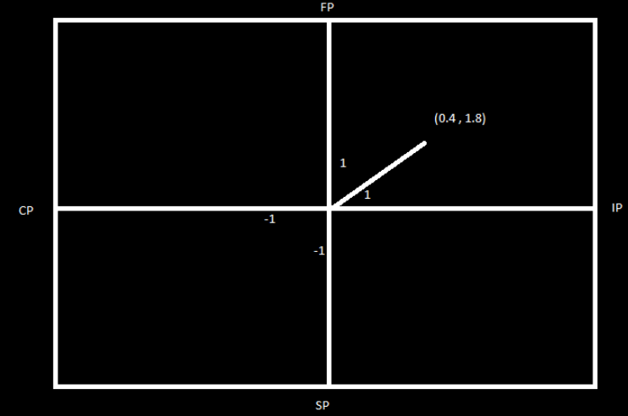

The SPACE, alternatively known as strategic position and action evaluation control, is the matrix that tends to determine the strategic position of a company with respect to four quadrants. The four quadrants represent four types of strategies present in the market which shows aggressive, competitive, conservative and defensive strategy. The first quadrant indicating positive signs on x and y axis falls under aggressive strategy. The second quadrant represents the conservative strategy where the sign is negative and positive. The third quadrant determines the defensive strategy where both the signs on x and y axis are negative. The fourth quadrant represents the competitive strategy where the signs on x and y axis are positive and negative. The position is analyzed on the basis of financial position, stability position, competitive position and industry position. From the analysis, the x axis shows a value of 0.4 and y axis shows a value of 1.8 indicating that EFU general insurance follows an aggressive strategy. In this sense, the company’s financial position is strong in a stable industry.

## Boston Consulting Group (BCG) Matrix

Relative Market Share

High (1.0) 0.5 Low (0.0)

Industry Growth Rate

High (+20)

0

Low

(-20)

The image above presents the BCG matrix applied on EFU general insurance which opines some strategic options available to EFU general insurance based upon their classification of products. The BCG matrix is based upon four quadrants based upon relative market share and industry growth rate. The product having high growth rate and high market share are called star products. Products having high growth rate but low market share are question market. Products having high market share and low growth rate are called cash cows and product having low market share and growth rate are termed as dog products.

In case of EFU general insurance, the company’s star product is motor insurance having high market share and high growth rate. In the question mark quadrant, the company’s marine insurance lies having low market share but high market growth. In the cash cow quadrant, EFU’s fire insurance lies which has high market share but the market growth late is low. In terms of dog products, EFU’s miscellaneous insurance lays which has a low market share and industry growth rate.

The company has following strategic choices regarding its products.

1. Motor insurance (Star)

* Market Development
* Horizontal, Forward and Backward Integration
* Market Penetration

2. Marine insurance (Question Mark)

* Market Development
* Product Development

3. Fire Insurance (Cash Cow)

* Market Development
* Market Penetration
* Joint Venture

4. Miscellaneous Insurance (Dog)

* Divestiture
* Retrenchment
* Liquidation

# Recommendations for EFU General Insurance

* The strongest product analyzed in the portfolio of EFU general insurance is motor insurance. However, company is targeting corporate clients’ more than individual clients. As the manager stated that he personally thinks that focus should be on individual customers rather than corporate clients because individual clients are likely to stay loyal in longer term but corporate clients pay high premium.
* The second recommendation is through their Takaful entity in general category. As the company is currently operating the Takaful window in general insurance yet, due to certain SECP, the company has now to open separate entity for Takaful operations and windows no longer can be operated. The potential for Takaful operations is high but the market is competitive with other businesses already have an established grip in Takaful market. EFU has all the necessary required resources and this might add to the portfolio and profitability of EFU insurance by extending its reach to Takaful market.
* Another emergent opportunity for EFU is China Pakistan Economic Corridor (CPEC) in Pakistan that will pave the way for many businesses and ventures and EFU has the opportunity to gain market by insuring the new businesses in Pakistan and EFU is at an advantage due to the strong brand name company possesses in Pakistani market.